Day 63: D Latch Using NAND and NOR Gates

Introduction: A D latch is a level-sensitive sequential circuit that stores one bit of data. It has a data input (D), an enable input (E), and outputs Q and Q̅. When enabled, the output follows the input; when disabled, it holds the previous state. This project implements a D latch using NAND gates, NOR gates, and behavioral modeling .

USING NAND GATE :

GATE_LEVEL:

Design:

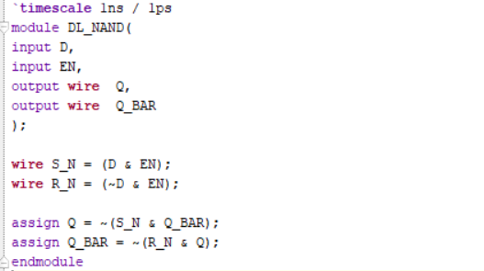

Schematic:

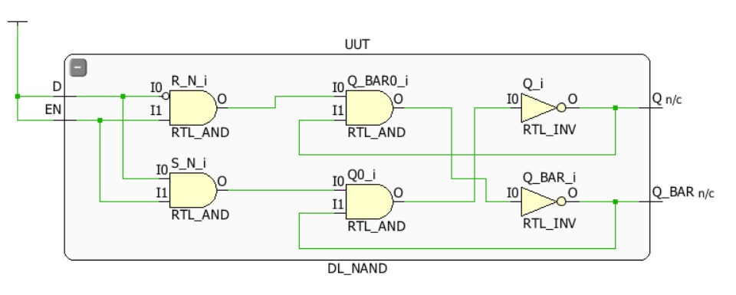

USING NOR GATE :

GATE_LEVEL:

Design:

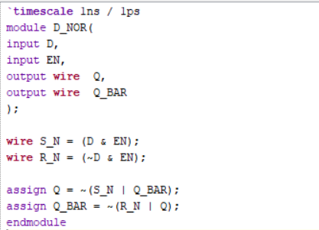

Schematic:

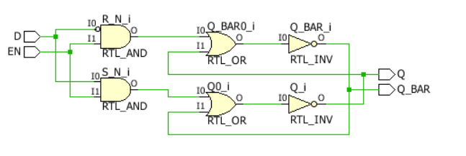

BEHAVIORAL_MODEL

Design:

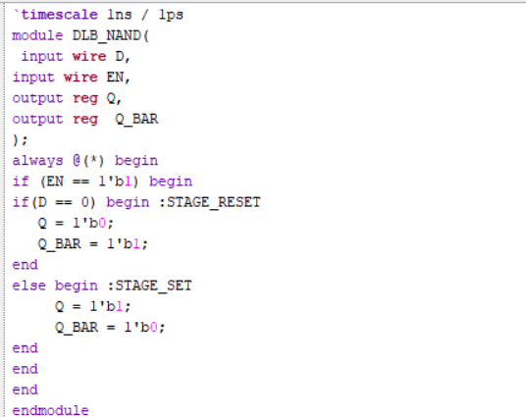

Schematic:

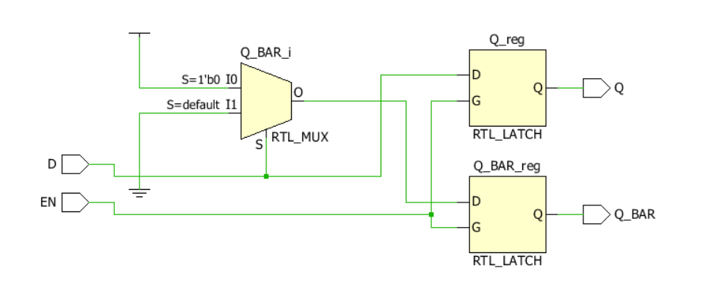

Testbench:

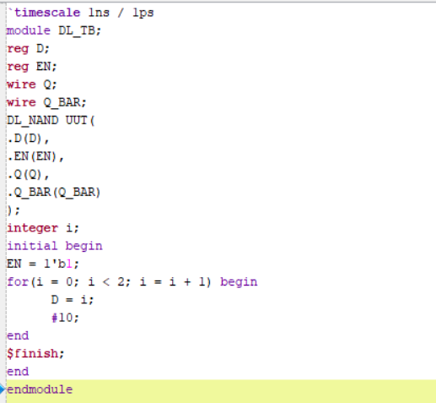

Waveform:

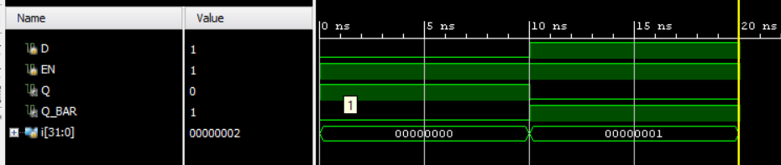

Observation:
The D latch was implemented using NAND gates, NOR gates, and behavioral modeling in Verilog HDL. The simulation waveforms were used to verify the output behavior. When the enable signal is active, the output follows the data input. When the enable signal is inactive, the latch retains its previous output. All three implementations demonstrate the basic data storage operation of a D latch.

